COURSE NAME: Theory of Computation COURSE CODE: CSA1304

COURSE OUTCOME COVERED

CO4: Construct Context-Free Grammars, generate derivations and parse trees to demonstrate the syntactic structure of strings. (BL : 3)

Assessment Tool Weightage: 10%

QUESTIONS: 10 Total Marks:100

Data Interpretation

Code of Conduct:

I SRIVARSHA M-192371010 (Name / Reg No) certify that this submission is my original work and that I have adhered to the guidelines specified for this assessment.
I understand that any violation of academic integrity rules will result in disciplinary action.

Signature of the student: SRIVARSHA M

Section A — Grammar: S → aSb | ab
This grammar generates strings of the form aⁿbⁿ (equal numbers of a's followed by equal numbers of b's, n ≥ 1). Every derivation applies the recursive rule S → aSb zero or more times and then closes with the terminating rule S → ab.

Q1. Language Identification — Which strings belong to the language?
- A) ab B) aabb C) aaabbb D) abb
Answer & Explanation
Correct options: A, B and C.
A) ab is generated directly by S → ab.
B) aabb is generated by S ⇒ aSb ⇒ a(ab)b = aabb.
C) aaabbb is generated by S ⇒ aSb ⇒ aaSbb ⇒ aa(ab)bb = aaabbb.
D) abb is NOT valid — the number of a's and b's must be equal, and abb has one a but two b's.

Q2. Pattern Recognition
- A) aⁿbⁿ B) (ab)ⁿ C) aⁿbᵐ D) (a+b)*
Answer & Explanation
Correct option: A) aⁿbⁿ, where n ≥ 1.
Each application of S → aSb adds one 'a' on the left and one 'b' on the right, keeping the counts equal, and S → ab supplies the base case n = 1.

Q3. Derivation Analysis — Valid derivation for aaabbb
- A) S → aSb → aaSbb → aaabbb
- B) S → ab → aabb
- C) S → aSb → ab
- D) S → aaSbb → aabb
Answer & Explanation
Correct option: A.
S ⇒ aSb (apply S → aSb once) ⇒ aaSbb (apply S → aSb again on the inner S) ⇒ aaabbb (apply S → ab on the last S).
Note: options B, C and D are invalid because they either try to derive further from a fully terminal string (B, C) or skip a required production step (D) — the grammar has no rule that removes S without producing 'ab'.

Q4. Missing Step Identification
S → aSb → aaSbb → ______ → aaabbb
- A) ab B) S C) ε D) aSb
Answer & Explanation
Correct option: A) ab.
The blank represents the terminating production applied to the last remaining S: aaSbb → aa(ab)bb = aaabbb. So the substitution used is S → ab.

Q5. Parse Tree Interpretation — Levels for aaabbb
- A) 2 B) 3 C) 4 D) 5
Answer & Explanation
Correct option: D) 4.
Level 1: root S. Level 2: a, S, b (from S → aSb). Level 3: a, S, b (from S → aSb again). Level 4: a, b (from S → ab).
The parse tree below shows all four levels.
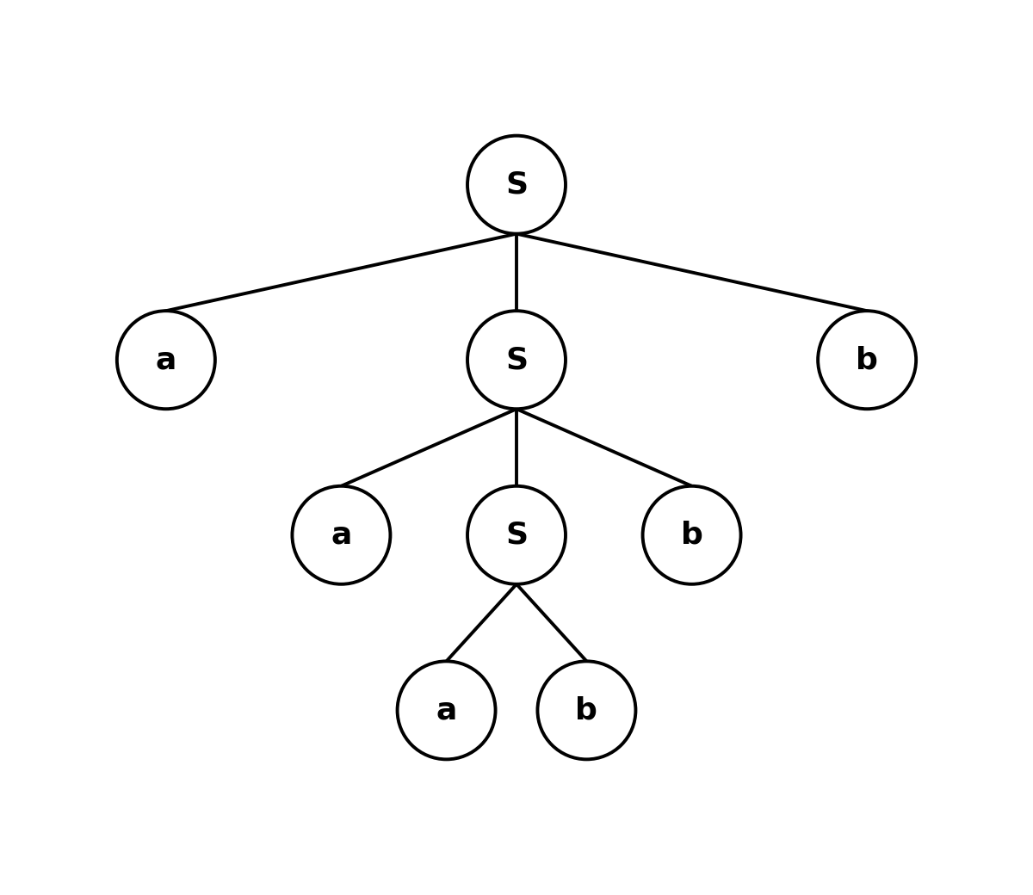
Figure 1: Parse tree for the string aaabbb using S → aSb | ab.

Section B — Grammar: S → SS | a
This grammar generates any non-empty string of a's (a, aa, aaa, ...), because S can be split into two S's any number of times before each S finally becomes a terminal 'a'.

Q6. Ambiguity Check
- A) Unambiguous B) Ambiguous C) Regular D) Deterministic
Answer & Explanation
Correct option: B) Ambiguous.
The string 'aaa' has more than one distinct leftmost derivation / parse tree, so the grammar is ambiguous (shown in Q8 below).

Q7. String Generation
- A) a B) aa C) aaa D) All of the above
Answer & Explanation
Correct option: D) All of the above.
a is generated directly by S → a. aa is generated by S ⇒ SS ⇒ aa. aaa is generated by S ⇒ SS ⇒ (SS)S ⇒ aaa (or an equivalent grouping). In general, any string of n a's (n ≥ 1) can be generated.

Q8. Interpretation of Ambiguity
- A) One string → one parse tree B) One string → multiple parse trees
- C) No derivation D) Infinite symbols
Answer & Explanation
Correct option: B) One string → multiple parse trees.
A grammar is ambiguous if at least one string in its language has two or more distinct parse trees (equivalently, two distinct leftmost derivations). The string 'aaa' below is one such example — it can be grouped as (a·a)·a or as a·(a·a).
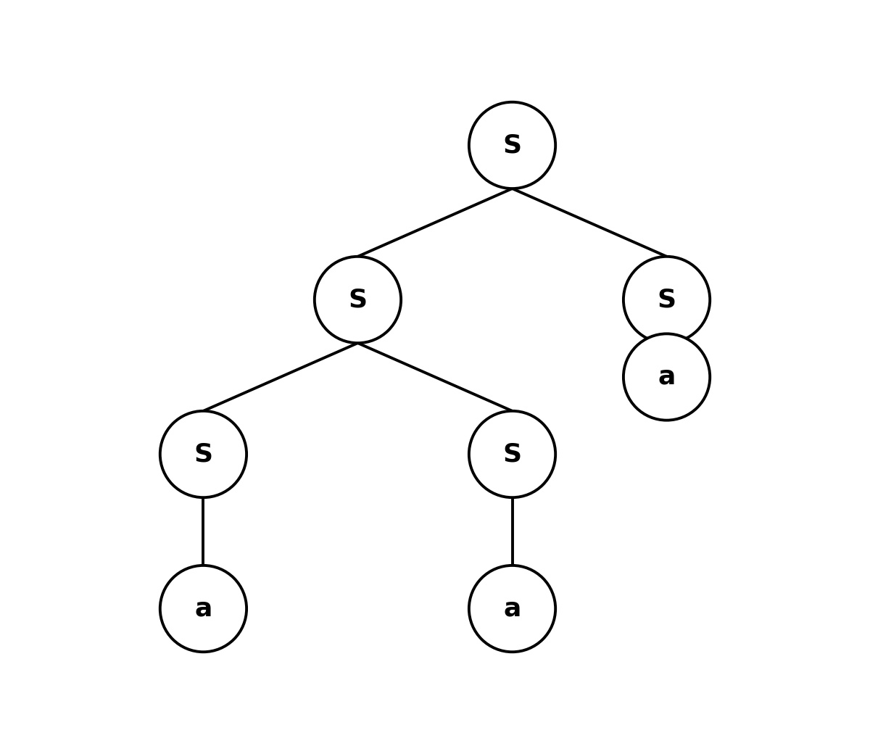
Figure 2a: Parse tree for 'aaa' — left grouping, S ⇒ SS ⇒ (SS)S ⇒ aaa.
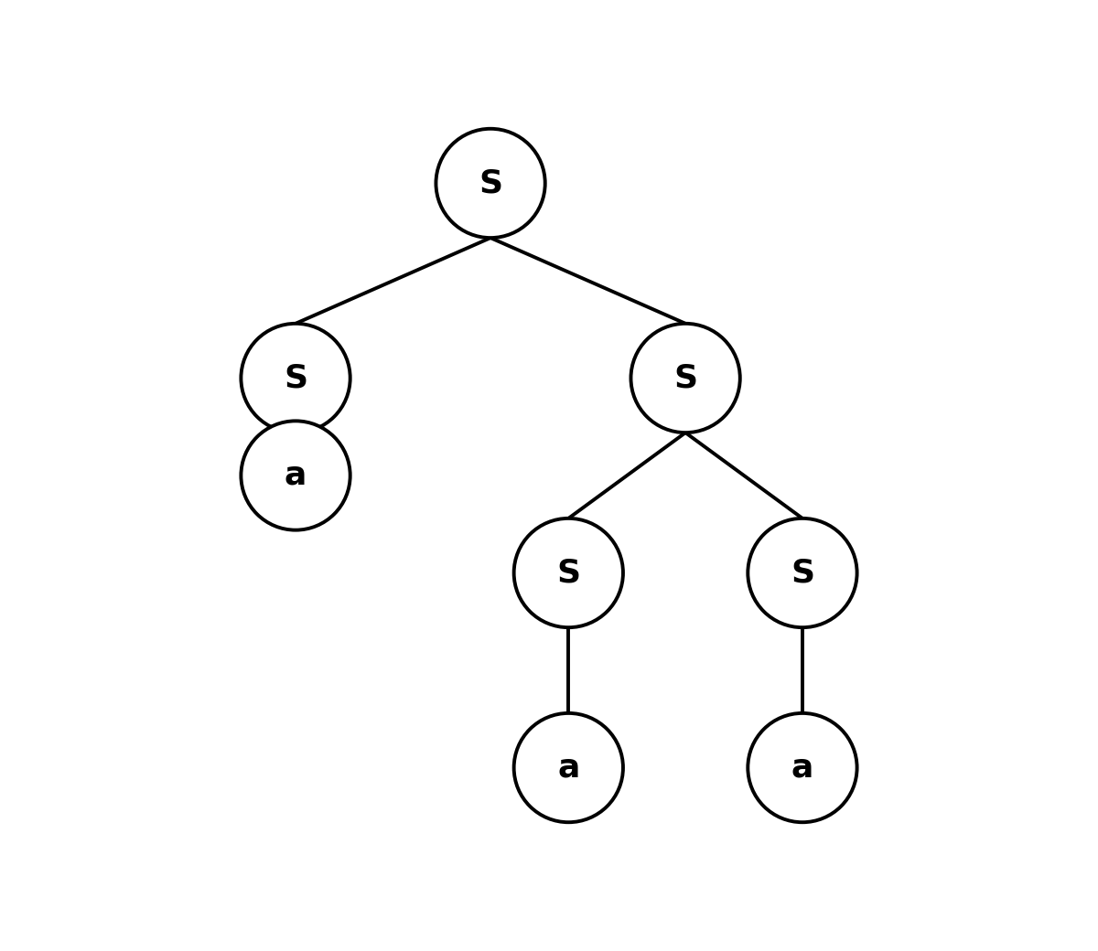
Figure 2b: Parse tree for 'aaa' — right grouping, S ⇒ SS ⇒ S(SS) ⇒ aaa. Two different trees for the same string confirm ambiguity.

Section C — Grammar 1: S → 0S1 | 01
This grammar generates strings of the form 0ⁿ1ⁿ over the alphabet {0, 1}, in exact parallel with the aⁿbⁿ grammar in Section A.

Q9. Derivation Interpretation — Which derivation correctly generates 0011?
- A) S → 0S1 → 00S11 → 0011
- B) S → 01 → 0011
- C) S → 0S1 → 01
- D) S → 00S11 → 0011
Answer & Explanation
Correct option: A (intended answer).
The clean, valid derivation of 0011 is: S ⇒ 0S1 ⇒ 0(01)1 = 0011 — apply S → 0S1 once, then close with S → 01.
Options B and C try to extend or shrink a fully terminal string, which is not allowed. Option D skips the first production step. Option A correctly shows the recursive rule being applied before the terminating rule, which is the general pattern the question is testing — apply S → 0S1 for each extra pair of symbols, then finish with S → 01.
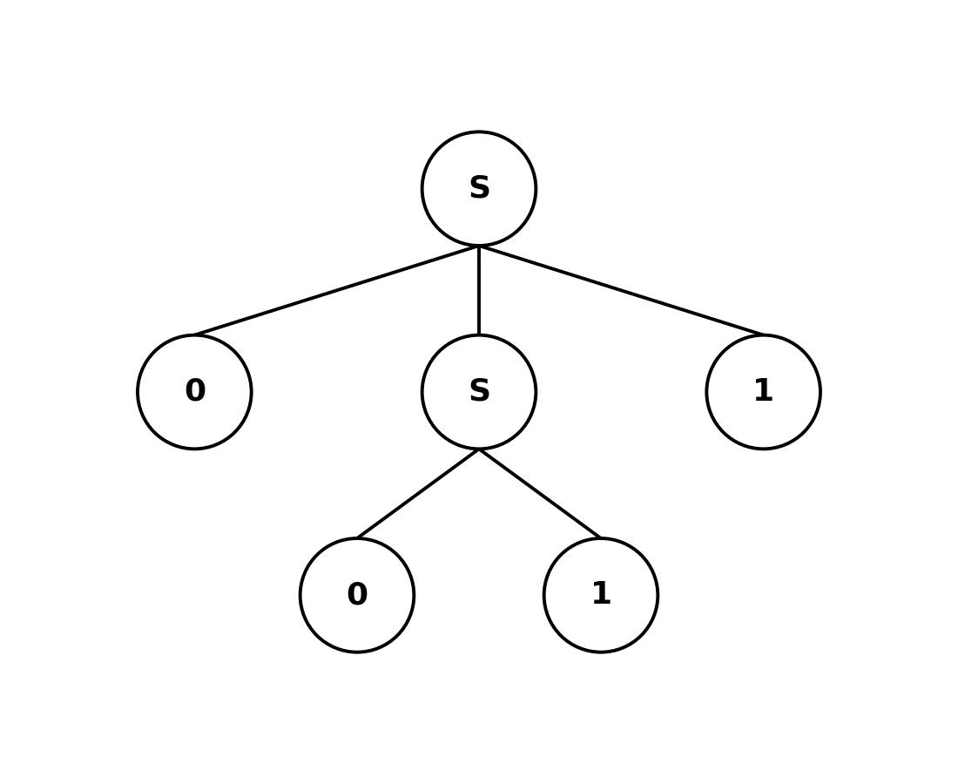
Figure 3: Parse tree for the string 0011 using S → 0S1 | 01.

Section D — Grammar 2: S → aS | Sb | ab
This grammar can prepend extra a's on the left (S → aS), append extra b's on the right (S → Sb), and always has the base case S → ab.

Q10. Structural Analysis — Which strings can be generated?
- A) ab B) aab C) abb D) All of the above
Answer & Explanation
Correct option: D) All of the above.
ab — generated directly by S → ab.
aab — generated by S ⇒ aS ⇒ a(ab) = aab.
abb — generated by S ⇒ Sb ⇒ (ab)b = abb.
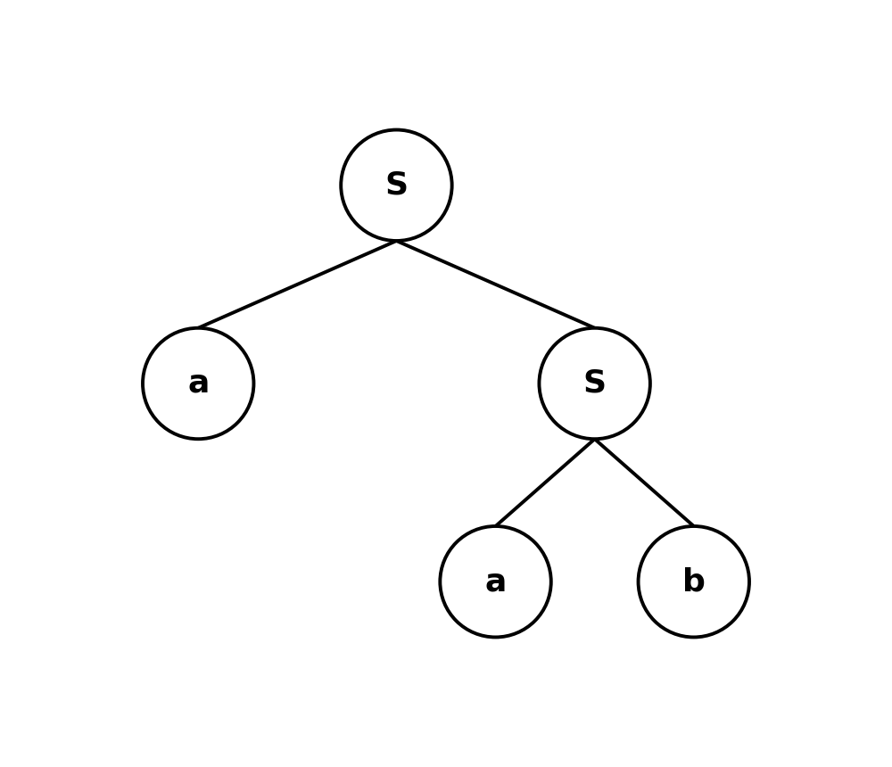

RUBRICS FOR CALCULATION

Criteria | Weightage | Level 4 –  Exemplary (5 Marks) | Level 3 –  Proficient (4 Marks) | Level 2 –  Developing (2–3 Marks) | Level 1 –  Beginning (0–1 Mark)
Conceptual Understandin g | 30 | Demonstrates clear and complete understanding of  the concept | Good understanding with minor gaps | Basic understanding with some misconceptions | Poor or incorrect understandin g
Accuracy of Answer | 25 | Completely correct answer  with no errors | Mostly correct with minor  errors | Partially correct with noticeable  errors | Incorrect or irrelevant  answer
Application of Knowledge | 20 | Correctly applies concepts to solve the  question/problem | Applies concepts with minor mistakes | Limited or partially correct application | No or incorrect application
Completeness of Response | 15 | Covers all required parts of the question | Covers most parts with minor  omissions | Covers only some parts | Incomplete or missing response
Clarity & Presentation | 10 | Clear, concise, and well-  organized answer | Understandabl e with minor  issues | Somewhat unclear or poorly  structured | Difficult to understand

